WEEKLY ACCOMPLISHMENT REPORT
(Week 1 – June - 2026)
Name of Intern | : | Lynus B.Fabroa
Position | : | Frontend Developer
Office | : | AQUILA Software Comp.
Date / Day |  |  | Actual Time Log |  | Actual Accomplishment
June 15.2026 | Monday |  | 10:30 A.M |  | INTERN Examination: Written and Hands-on
June 16,2026 | Tuesday |  | 10:30 A.M |  | Orientation and fixing 19 bugs for backend of Library MS
June 17,2026 | Wednesday |  | 10:30 A.M |  | Assign to create an inventory system using CRUD
June 18,2026 | Thursday |  | 10:30 A.M |  | Continuation of creating inventory system
June 19,2026 | Friday |  | 10:30 A.M |  | Demonstration of the inventory system and submitting the fixed 19 bugs of Library MS backend (WFH)
TOTAL HOURS: 40.5 hrs REMAINING HOURS: 283.5
Prepared by: |  |  |  |  |  | Verified by:
Lynus B. Fabroa |  |  |  |  | VIRGILIO F. TUGA JR. , MSCS (CAR)
Name & Signature of Intern |  |  |  |  | OJT Coordinator

Documentation (Insert images by day, label the exact date)

- June 15,2026
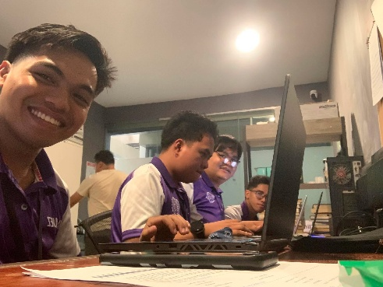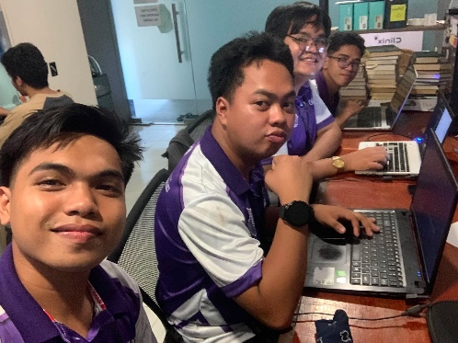
- June 16,2026
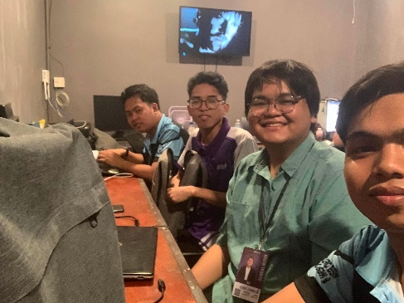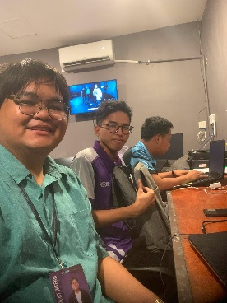
- June 17,2026
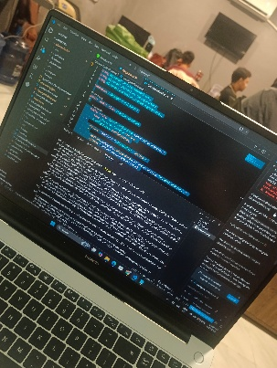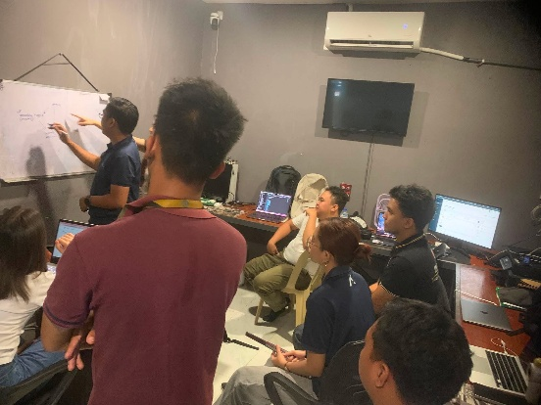
- June 18,2026
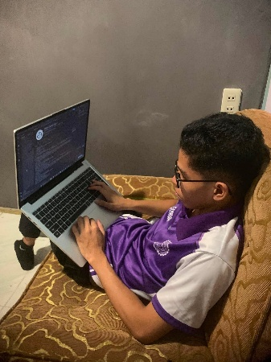

WEEKLY ACCOMPLISHMENT REPORT
(Week 2 – June - 2026)
Name of Intern | : | Lynus B.Fabroa
Position | : | Frontend Developer
Office | : | AQUILA Software Comp.
Date / Day |  |  | Actual Time Log |  | Actual Accomplishment
June 22.2026 | Monday |  | 10:30 A.M |  | On-boarding: Introduction to system we assign for us;  In development Accounting System.
June 23,2026 | Tuesday |  | 10:30 A.M |  | On-boarding: Exploring the system UI workflow
June 24,2026 | Wednesday |  | 10:30 A.M |  | On-boarding: Meeting with the accounting manager for the system workflow and changes
June 25,2026 | Thursday |  | 10:30 A.M |  | Connecting the backend and frontend to make the UI functional for testing
June 26,2026 | Friday |  | 10:30 A.M |  | Updated the journal entry pages with redesigned layout and improved data handling
TOTAL HOURS: 40.5 hrs REMAINING HOURS: 243 hrs
 |  |  |  |  |  | Verified by:
Lynus B. Fabroa |  |  |  |  | VIRGILIO F. TUGA JR. , MSCS (CAR)
Name & Signature of Intern |  |  |  |  | OJT Coordinator

Documentation (Insert images by day, label the exact date)
- June 22,2026
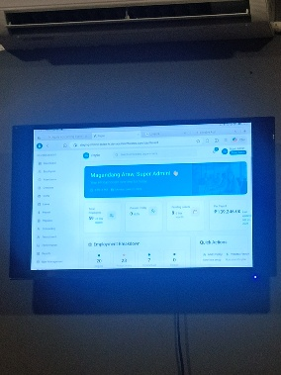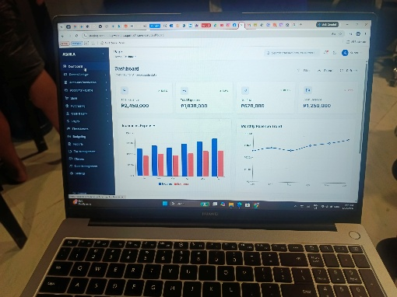
- June 23,2026
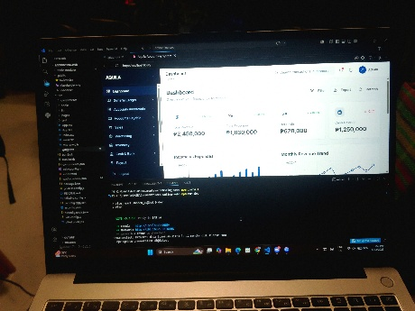
- June 24,2026
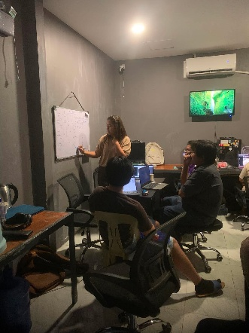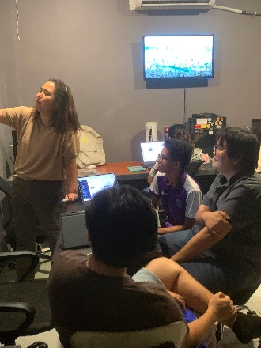
- June 25,2026
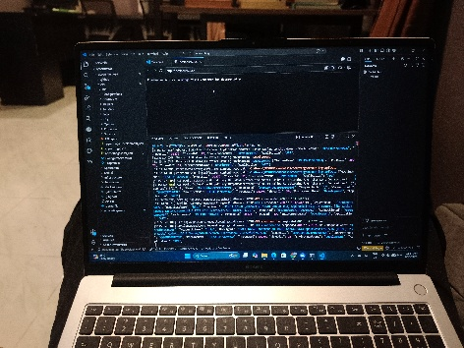

- June 26,2026
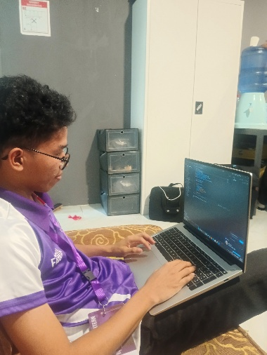

WEEKLY ACCOMPLISHMENT REPORT
(Week 3 – June/July - 2026)
Name of Intern | : | Lynus B.Fabroa
Position | : | Frontend Developer
Office | : | AQUILA Software Comp.
Date / Day |  |  | Actual Time Log |  | Actual Accomplishment
June 29.2026 | Monday |  | 10:30 A.M |  | Successfully refactor(classes) the UI, pulling request to project manager for ready to merge the changes.
June 30,2026 | Tuesday |  | 10:30 A.M |  | Receive update from Project manager about the merge from the pull request
July 1,2026 | Wednesday |  | 10:30 A.M |  | Assign to edit a video for event held in Grand Regal Hotel, Davao City
July 2,2026 | Thursday |  | 10:30 A.M |  | Continuation of editing for Video no.3
July 3,2026 | Friday |  | 10:30 A.M |  | Uploading the finished edited video in Google drive for checking; ready to post
TOTAL HOURS: 40.5 hrs REMAINING HOURS: 202.5 hrs
Prepared by: |  |  |  |  |  | Verified by:
Lynus B. Fabroa |  |  |  |  | VIRGILIO F. TUGA JR. , MSCS (CAR)
Name & Signature of Intern |  |  |  |  | OJT Coordinator

Documentation (Insert images by day, label the exact date)
- June 29,2026
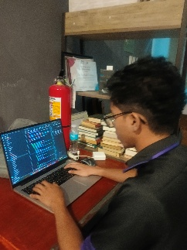
- June 30,2029
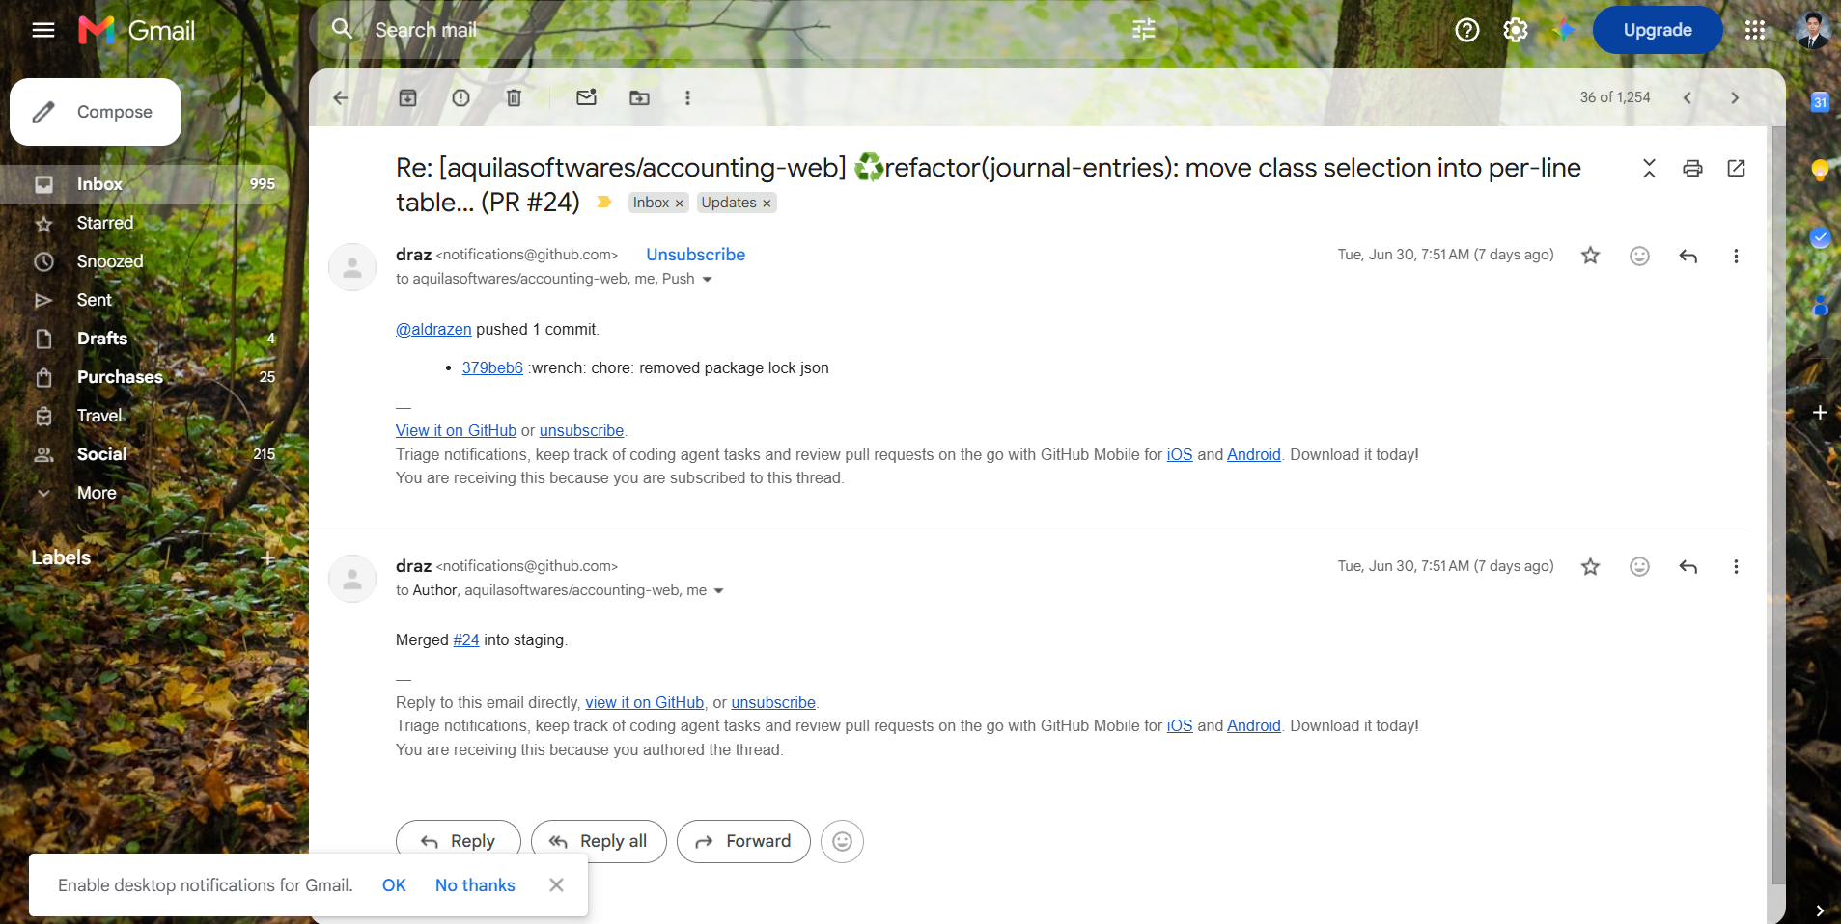
- July 1,2026
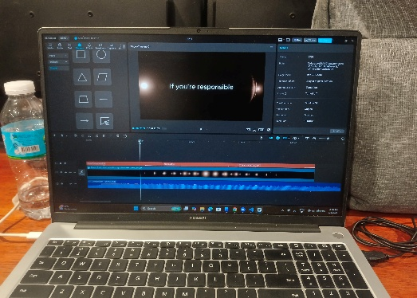
- July 2,2026
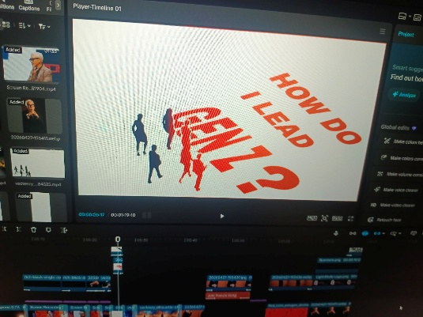
- July 3,2026
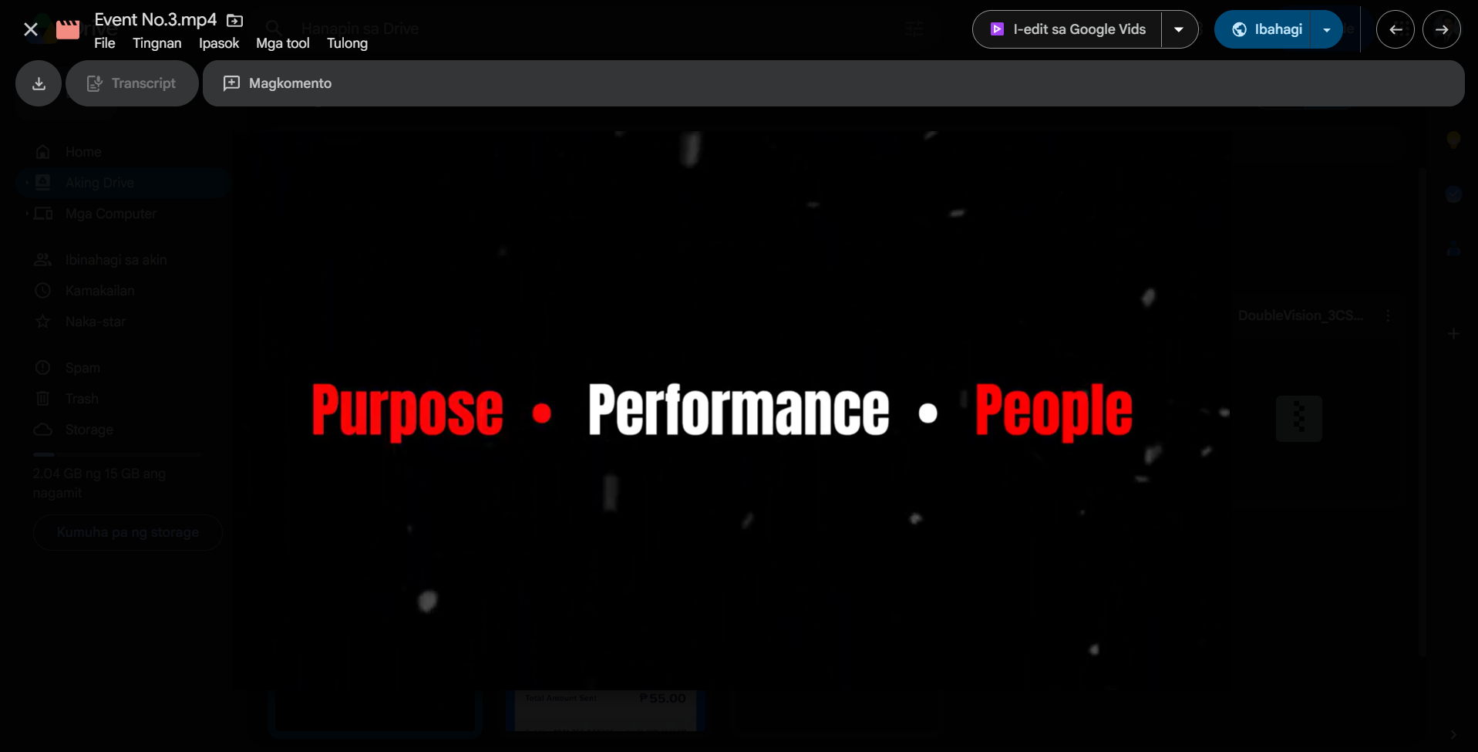

(Week 4 – July - 2026)
Name of Intern | : | Lynus B.Fabroa
Position | : | Frontend Developer
Office | : | AQUILA Software Comp.
Date / Day |  |  | Actual Time Log |  | Actual Accomplishment
July 6.2026 | Monday |  | 10:30 A.M |  | Continuation of enhancement UI for accounting system for better responsive in each page in menu.
July 7,2026 | Tuesday |  | 10:30 A.M |  | Meeting with the project manager for the report of last week task.
July 8,2026 | Wednesday |  | 10:30 A.M |  | Assign for creating/editing an demonstration video for company application the Clinix+ app
July 9,2026 | Thursday |  | 10:30 A.M |  | Continuation of editing for the demonstration/ tutorial video.
July 10,2026 | Friday |  | 10:30 A.M |  | Finishing the total of 7 tutorial video
TOTAL HOURS: 40.5 hrs REMAINING HOURS: 162 hrs
Prepared by: |  |  |  |  |  | Verified by:
Lynus B. Fabroa |  |  |  |  | VIRGILIO F. TUGA JR. , MSCS (CAR)
Name & Signature of Intern |  |  |  |  | OJT Coordinator

Documentation (Insert images by day, label the exact date)
- July 6, 2026
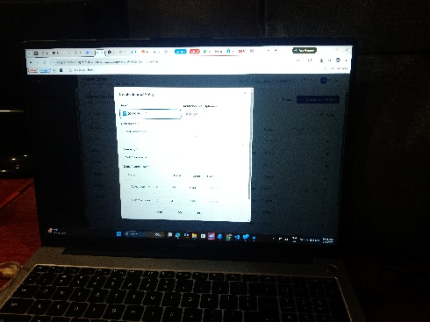
- July 7,2026
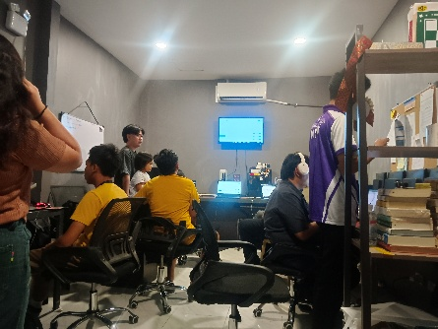
- July 8, 2026
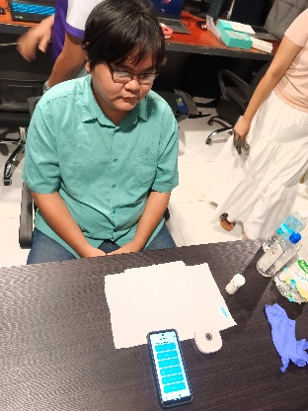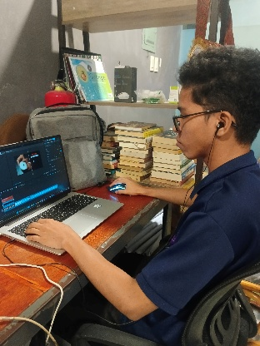
- July 9, 2026
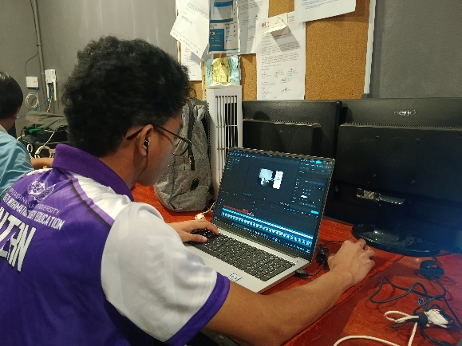
- July 10, 2026
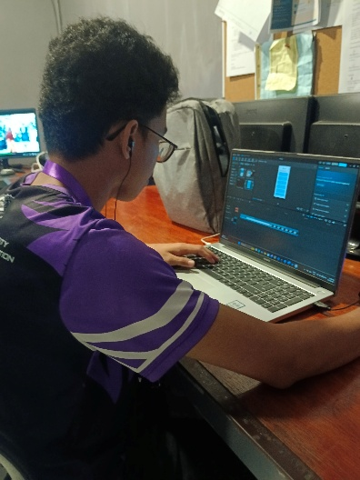

(Week 5 – July - 2026)
Name of Intern | : | Lynus B.Fabroa
Position | : | Frontend Developer
Office | : | AQUILA Software Comp.
Date / Day |  |  | Actual Time Log |  | Actual Accomplishment
July 13.2026 | Monday |  | 10:30 A.M |  | Meeting with the company developer for the progress of each system.
July 14,2026 | Tuesday |  | 10:30 A.M |  | Continuation for enhancement of UI especially fixing the payslip of each employee.
July 15,2026 | Wednesday |  | 10:30 A.M |  | Testing the updated UI and function of the paysllip page.
July 16,2026 | Thursday |  | 10:30 A.M |  | Pulling a new updated backend to proceed for full testing between frontend and backend.
July 17,2026 | Friday |  | 10:30 A.M |  | Polishing the UI to check bugs and error.
TOTAL HOURS: 40.5 hrs REMAINING HOURS: 121.5 hrs
Prepared by: |  |  |  |  |  | Verified by:
Lynus B. Fabroa |  |  |  |  | VIRGILIO F. TUGA JR. , MSCS (CAR)
Name & Signature of Intern |  |  |  |  | OJT Coordinator

Documentation (Insert images by day, label the exact date)
- July 13, 2026
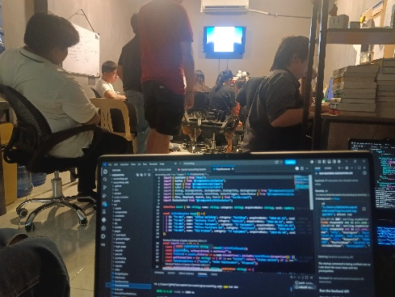
- July 14, 2026
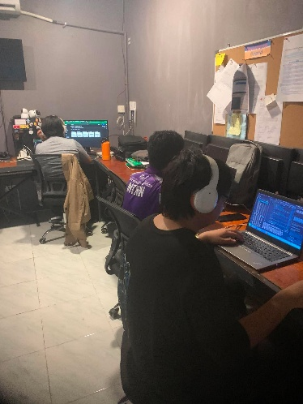
- July 15, 2026
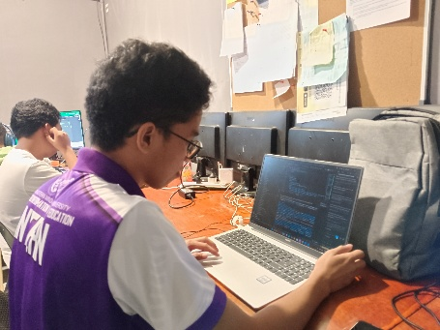
- July 16, 2026
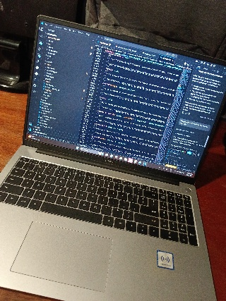
- July 17, 2026
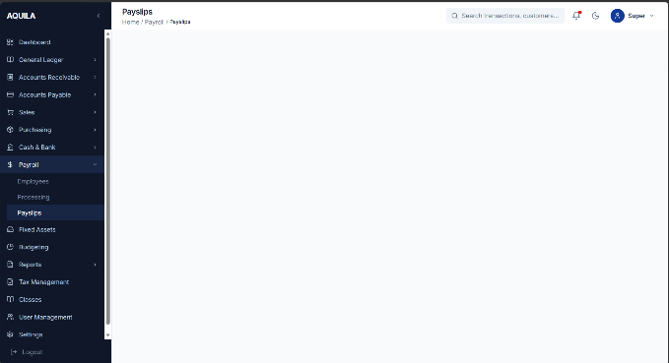

(Week 6 – July - 2026)
Name of Intern | : | Lynus B.Fabroa
Position | : | Frontend Developer
Office | : | AQUILA Software Comp.
Date / Day |  |  | Actual Time Log |  | Actual Accomplishment
July 20.2026 | Monday |  | 10:30 A.M |  | Meeting with project manager for the last week progress.
July 21,2026 | Tuesday |  | 10:30 A.M |  | Assign to proceed for the next task to fix the payroll page to be functional.
July 22,2026 | Wednesday |  | 10:30 A.M |  | Invited in Sploop Arcade Davao for the business advertising.
July 23,2026 | Thursday |  | 10:30 A.M |  | Continuation of assigned task testing and debugging for frontend.
July 24,2026 | Friday |  | 10:30 A.M |  | Polishing the UI to check bugs and error for employee, payroll processing, and payslip page.
TOTAL HOURS: 40.5 hrs REMAINING HOURS: 81 hrs
Prepared by: |  |  |  |  |  | Verified by:
Lynus B. Fabroa |  |  |  |  | VIRGILIO F. TUGA JR. , MSCS (CAR)
Name & Signature of Intern |  |  |  |  | OJT Coordinator

Documentation (Insert images by day, label the exact date)
- July 20, 2026
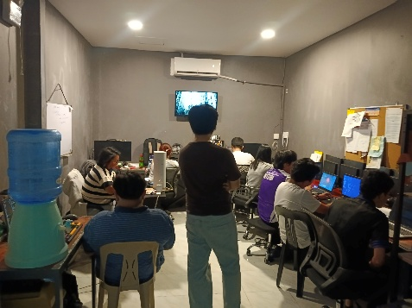
- July 21, 2026
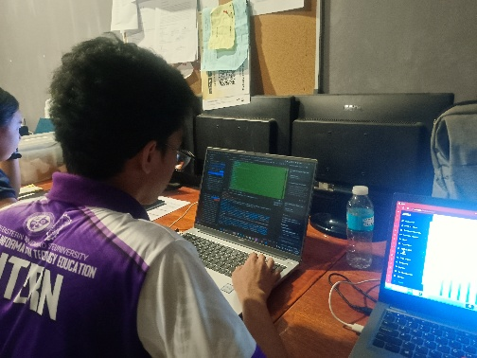
- July 22, 2026
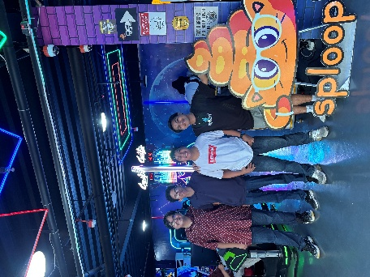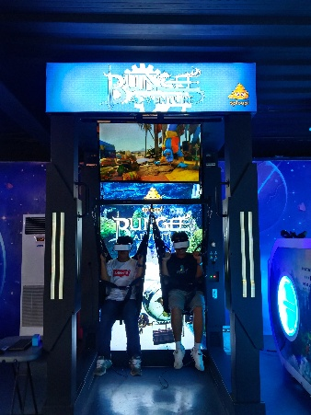
- July 23, 2026
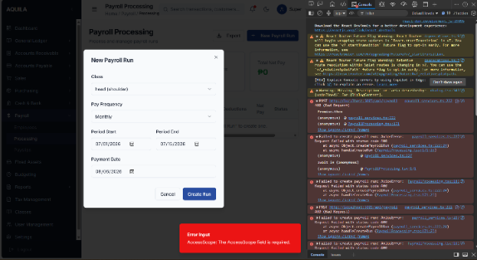
- July 24, 2026
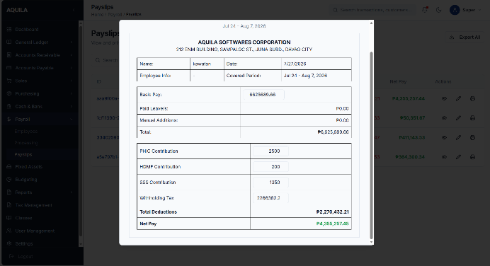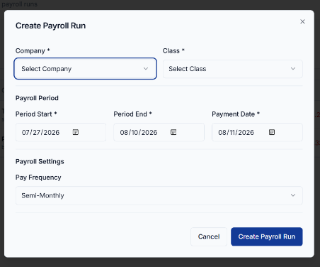

(Week 7 – July - 2026)
Name of Intern | : | Lynus B.Fabroa
Position | : | Frontend Developer
Office | : | AQUILA Software Comp.
Date / Day |  |  | Actual Time Log |  | Actual Accomplishment
July 27.2026 | Monday |  | 10:30 A.M |  | Updating the system. Checking for the new merge update. Meeting with the company dev.
July 28,2026 | Tuesday |  | 10:30 A.M |  | Meeting with the project manager for the work accomplishment last week. Taking notes for the enhancement and suggestion.
July 29,2026 | Wednesday |  | 10:30 A.M |  | Starting working for the suggestion enhancement of the website.
July 30,2026 | Thursday |  | 10:30 A.M |  | Cleaning the office. Continuation of assigned task testing and debugging for frontend.
July 31,2026 | Friday |  | 10:30 A.M |  | Invited for the company training for AI automation and quality assurance
TOTAL HOURS: 40.5 hrs REMAINING HOURS: 40.5 hrs
Prepared by: |  |  |  |  |  | Verified by:
Lynus B. Fabroa |  |  |  |  | VIRGILIO F. TUGA JR. , MSCS (CAR)
Name & Signature of Intern |  |  |  |  | OJT Coordinator

Documentation (Insert images by day, label the exact date)
- July 27, 2026
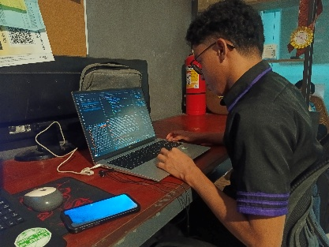
- July 28, 2026
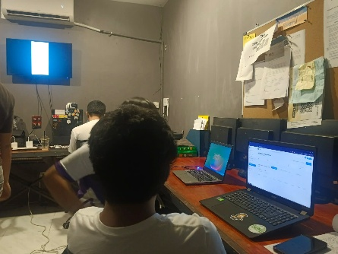
- July 29, 2026
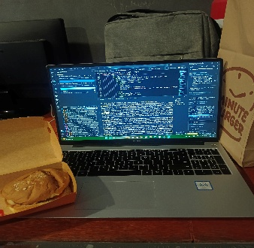
- July 30, 2026
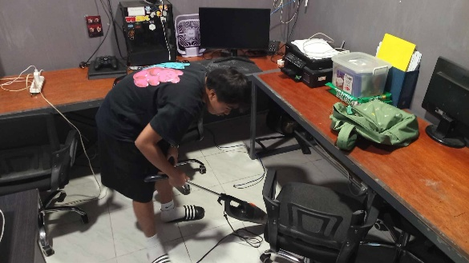

- July 31, 2026
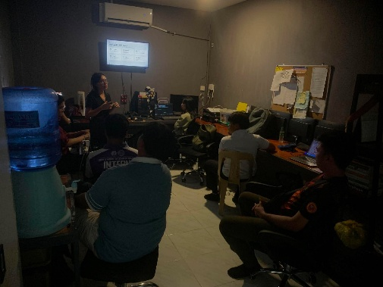

(Week 7 – July - 2026)
Name of Intern | : | Lynus B.Fabroa
Position | : | Frontend Developer
Office | : | AQUILA Software Comp.
Date / Day |  |  | Actual Time Log |  | Actual Accomplishment
August 3,2026 | Monday |  | 10:30 A.M |  | Meeting with the project manager for the work accomplishment last week and also the final task for the final week
August 4,2026 | Tuesday |  | 10:30 A.M |  | Create pull request for the merge of the new update for the frontend of the system.
August 5,2026 | Wednesday |  | 10:30 A.M |  | Resolving a problem based on the error during merging of the update.
August 6,2026 | Thursday |  | 10:30 A.M |  | Create a send pull request for another update of the frontend.
August 7,2026 | Friday |  | 10:30 A.M |  | Final day of the work. Makin sure the accomplish work already done.
TOTAL HOURS: 40.5 hrs REMAINING HOURS: 0 hrs
Prepared by: |  |  |  |  |  | Verified by:
Lynus B. Fabroa |  |  |  |  | VIRGILIO F. TUGA JR. , MSCS (CAR)
Name & Signature of Intern |  |  |  |  | OJT Coordinator

Documentation (Insert images by day, label the exact date)
- August 3, 2026
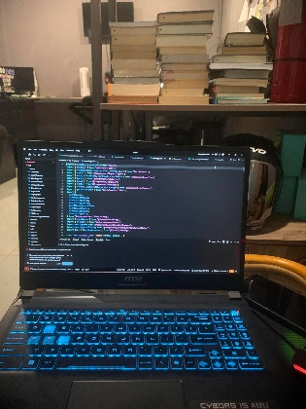
- August 4, 2026
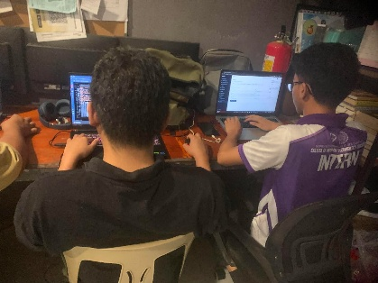
- August 5, 2026
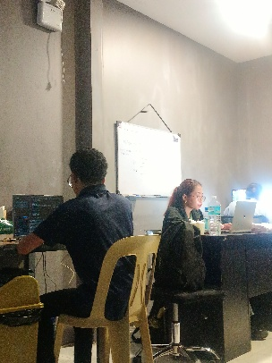

- August 6, 2026
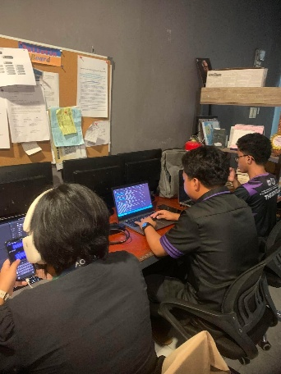
- August 7, 2026
